ECHO
Encrypted CHat Online service
Marshall Crumiller and Jonathan Pearson

Introduction
In today’s world, communication is by no means safe. People send email, Instant Messages, and file transfers wide out in the open; anyone can “snoop in” and read entire conversations of potentially confidential information. Most users are completely oblivious to this fact; others simply don’t care. For those who do, however, we intend to provide a simple and easy means of communication that, by today’s standards, remains almost completely secure.

Our project delivers a full instant-messaging chat service similar to AOL Instant Messenger (AIM), which allows users to type to each other via text windows. The messages sent across open channels are encrypted with RSA encryption, one of the most secure encryption algorithms known today. The ECHO chat service is easy to use and completely secure.

Overview of the Project
Our project is split into two distinct entities that interact: the client and the server. The client is the user interface that users would use to login their registered “screenname” and send messages to other users who are logged in. However, logging in requires passwords, and anonymity of person requires anonymity of location, and thus all messages are routed through the server as well. As such, the client serves to interact with other users, but only through the server, which functions as a “user manager.”

Registration
The registration component was created with an easy and common web-interface in mind. To do so one visits http://echoes.hopto.org/CS/signup.html and fills in the given form. I created these pages in HTML using PHP, which processes all of the results and connects to the MySQL database to input the information. In addition, there are various checks to ensure that no two screennames are the same, no two emails are the same, correct passwords are inputted. In addition, halfway through the registration process the user is emailed with a randomly generated confirmation code which must then be inputted into the form for the user to be “confirmed” (before the user is confirmed he/she may not log on.

The Client
The chat client is built to be user friendly and simple to use. It provides an interface that AOL Instant Messenger (AIM) users are likely to understand, with the extra feature of tabbing. The menus and interface buttons are designed to be easy to find for any AIM user. To use the client, one must first log into the system. Once logged in, a friendly buddy-list is displayed to allow quick contact to well-known buddies, and it is easily editable. The chat window is brought up with a buddy is double-clicked, and provides secure communication through the server to that buddy.
The login process works by creating a TCP connection to the server, which should be running on a separate machine. The server will send its public RSA key and a randomly generated integer, the “salt”, over this connection as soon as it is established. The client responds by sending its own public key, followed by the user name and password, interleaved with the salt, encrypted with the server’s public key. The server will respond with “Accepted” or “Rejected” encrypted with the client’s public key. If the client receives the message “Accepted”, it will display the buddy list.
The buddy list serves as a convenient place to find people that are talked to commonly. When a chat session is initiated with one of the users on the list, the chat window is displayed if it was hidden, and a new tab for the conversation is created. As it opens, a message is sent to the server requesting the public key of that buddy, and when the public key is received the “Send” button is enabled. Messages are in Rich Text Format (RTF), and are encrypted with the receiver’s public key. The names of the sender and receiver are encrypted with the server’s public key. The encrypted names serve as a header so the server knows where to send the message, and are re-encrypted and forwarded to the other client.
When a message is received, the name of the sender is used to route it to the proper receiver tab, and a new tab is created if necessary. The message is decrypted and displayed.

The Server
When the server boots up, it connects to a MySQL server stored on the host machine. This SQL database houses information about each user—both logged-in users and logged-out users. The database has a table named “users” with the following fields:

Field | Type | Description
username | varchar(15) | Screenname of the user
password | varchar(255) | MD5-hash of the username’s password
email | varchar(50) | Email address of the user
confirm | varchar(10) | Confirmation code given to the user upon registration
confirmed | integer | Tells whether the user has confirmed his/her registration
iPAddress | Varchar(255) | String-representation of the user’s current IP Address
inTime | varChar(255) | The time at which the user logged in (or –time if user was rejected)
invalidcount | integer | Number of times user has unsuccessfully tried to log in (max 3)
publickey | Varchar(255) | The RSA-public key of the user

Server.java
The server is invoked with the command “java Server,” which calls the main() function in Server.java. Here initialize() is called, which first creates new RSA public and private key pair via the RSAKey class, and then boots up the SQL database. To do so, we first load the appropriate JDBC msql driver (downloaded and packaged with the project) and create a connection with a supplied username and password at the prompt. The password at the prompt masked with the MaskingThread class created by Qusay H. Mahmoud from Sun Microsystems. It continuously reads from input and “unreads,” replace the input with the * character. Once the username and password to the server is input, the database is loaded up. The server then beings three different threads—User, UDPWaiter, and TCPWaiter. User is a thread that runs a command prompt for the administrator to query and shut down the server. TCPWaiter continually loops on port 5380 and listens for an incoming TCPConnection (a login). UDPWaiter continually loops on port 5381 and listens for an incoming UDP packet (a message). When a login request is detected, a Login thread is spawned. When a message is detected, a Message thread is spawned.

Login.java
Login.java deals with a user attempting to log in. The following steps are followed when a TCP connection is received:
Server sends the user (in plaintext) its public key.
Server sends the user (in plaintext) a random integer “salt.”
Server receives an encrypted username/salt and password/salt combination. The salt is used here so that the encryption of the username and password appear different every time. All encryption is done through the RSAKey class. The actually password is never seen; only an MD5 hash of the password is compared to the MD5 hash of the password stored in the database, so passwords are even private from administrators. The MD5 function used in Java was taken from the com.Ostermiller.util Java Utilities site.
The server then queries the database for the user. If the user exists, it beings a series of checks:
If the user has unsuccessfully tried to log in three times within the past 30 minutes, he is immediately denied (this is done by checking the last time the user tried to log in (which is stored as a negative value of the current time) and compared to the current time; if the time difference is less than 30 minutes, the user is rejected. If greater than 30 minutes, the “invalidCount” is reset to 0.
If the user’s password is incorrect but invalidCount is less than 3, invalidCount is incremented and the user is rejected.
If the user’s account has not been confirmed, the user is rejected.
If the user’s password hash matches the hash stored in the database, the users IP Address, public Key, and login time is stored in the database, and the user is sent an encrypted message “Accepted\n”, and the thread quits.

Message.java
When a UDP packet is detected, a Message thread is spawned to deal with its contents. A Message consists of a DatagramPacket and a String containing the data within the packet. When this message is received, it is composed of the following form:

Headers\n
Message

The IP of the sender is first and foremost compared to the IPAddress stored in the database to ensure that the user is sending from where he/she said he is.

The Headers is then parsed as follows:
If the first line of Headers is “logout”, the user intends to log out. In this case, set the user’s IPAddress and inTime to null.
If the first line of Headers is “request,” then a user would like to know another user’s public key. In this case, look up that user in the database (retrieve public key), and send a packet back to the requestor with the user’s key. If the user isn’t online, send an Error packet.
If the first line of Headers is “msg,” then the user would like to send a message to another user. The next two lines of the message then tell who the sender is and who the receiver is. The Server then looks up the receiver’s information, encrypts the new headers with the receiver’s public key, and sends the message along its way to the new receiver.

RSAKey.java
The RSAKey class is derived from Jonathan’s hybrid project. It creates a random public and private key, which uses various tests to determine primality, including the Rabin-Miller test, a modular-inverse calculator (we used my super slick version for this, see the modInverse function in Utils.java), and a modular exponent function. The new functions added were to assist in sending encrypted text through an input/output stream, or simply to just encrypt a string and return another string. The four functions written here were sendText(), getText(), encryptString(), and decryptString(). The process for these two pairs of functions is identical: to encrypt, given a string, we continually grab up to 8 characters. These characters are converted into 2-digit ascii hex values (hex so that the #digits is always 2—in the event of a ‘\n’ = 0xF we add a “0” to the front) and packed together, so that the string “abcd” will form “61626364”. This string is then converted to a bigInteger, which is then encrypted and shipped out. Each chunk of 8 is divided by a plaintext ‘\t’, and the final message is appended with a ‘\n’. The decryptor function then reads some test of the form “x…x\tx…x\tx…x\n”. It grabs the first 16 characters, decrypts with the key, then successively grabs every 2 characters, converts it to a hex value, and converts back to a character. These characters are all concatenated and returned as a string. Thus an entire “message” of any size can be encrypted, sent, decrypted, and viewed transparently.

Overview of Server files:
hexTest.java – a file that tests the encryption and decryption function found in the RSAKey() class.
Login.java – Thread that processes user login, described above.
MaskingThread.java – described above, masks the user’s password input on the command console.
MD5.java – a class used to create a quick MD5 hash of a user’s password (so the real password need not be stored).
Message.java – Thread that processes incoming UDP packets.
PasswordField.java – helper class to MaskingThread.java
RSAKey.java – class to generate and use public and private RSA keys.
RSAKeyGen.java – helper class for RSAKey.java.
Server.java – Main Server class, described above.
TCPWaiter.java – Thread that listens for incoming TCP connections.
UDPWaiter.java – Thread that listens for incoming UDP packets.
User.java – Thread that listens for command-line user input.
Utils.java – helper classes for RSAKey.java
Mysql-connector-java-3.0.16-ga-bin.jar – Contains driver classes and functions for interacting with MySQL environment.

Overview of Client Files:
AddBuddy.cs - A form to allow the user to add new buddies to the buddy list
Buddy.cs - Represents a buddy, whether a chat session is open, the key of the buddy, whether the buddy is ready to chat (we have the key), the tab that is used to chat with this buddy…
BuddyList.cs - The buddy list form
BuddyTree.cs - Represents the buddies and branches on the buddy list form
EncryptedInputStream.cs - Used to read the keys for this machine, encrypted with the password of the user hashed with SHA1
EncryptedOutputStream.cs - Used to save the keys for this machine, encrypted with the password of the user hashed with SHA1
Form1.cs - The chat window
GenerateKey.cs - Generates a new key for the user
Login.cs - The login form
MessageListener.cs - A separate thread that listens for Datagram messages from the server and routes them properly
RSAKey.cs - Represents an RSA key, allows for encryption of strings and data (encryption with the public key followed by encryption with the private key is equivalent to decryption, so no decrypt method is provided)
Utils.cs - General utilities, including a database of knowledge that is kept up while the program runs. Contains objects used by many other objects that need a common location to be retrieved.

Files not mentioned above were auto-generated or have been replaced by other methods of doing things.

Using ECHO

To begin, one must register a username and password.
Visit http://echoes.hopto.org/CS/signup.html and fill in the following form:
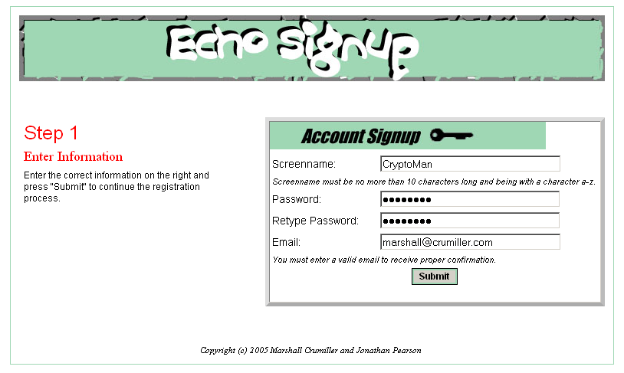
After entering this information, the user receives an email from echosignup@echo.com similar to the following:

Dear CryptoMan,
Thank you for signing up for ECHO. You have just one more step to go before you can log in to our ECHO server. To confirm your membership, please copy the following confirmation code:
xmuRtUpf
into the confirmation box located here
We hope you enjoy!
Sincerely,
the ECHO design team

The user then enters the code into the box as follows:
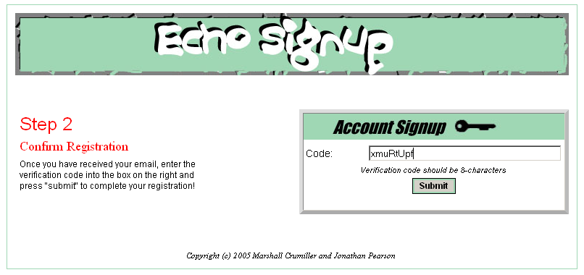

And upon pressing “submit” the user receives a greeting:
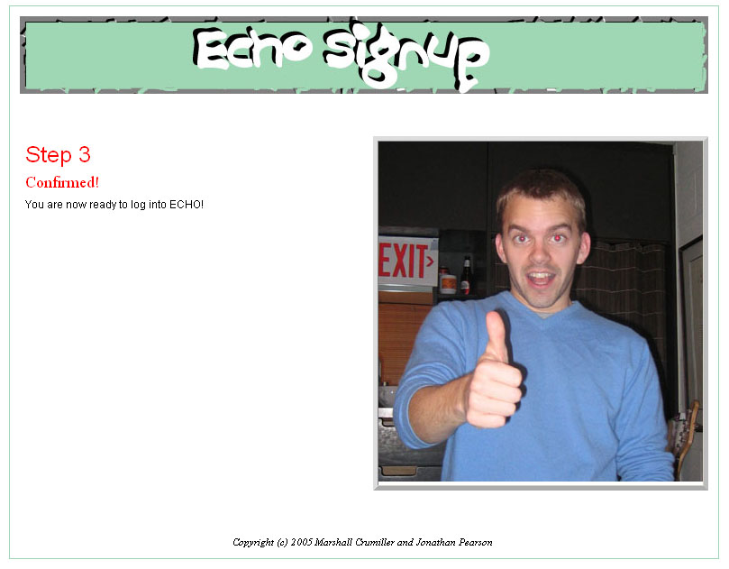

To test it out yourself, you can go to http://sigep.hopto.org/CS/signup.html (we’ll get a better location later, this is just for now).

Mahmoud, “Password Masking in the Java Programming Language.” http://java.sun.com/developer/technicalArticles/Security/pwordmask/ Copyright 1994-2004 Sun Microsystems, Inc.
com.java.Utilities Java MD5 package, http://ostermiller.org/utils/MD5.html Copyright (c) 2001-2004 by Stephen Ostermiller and other contributors

